Physiotherapy Self-Referral Form
Please Note – This form should be used to access Physiotherapy for one musculoskeletal complaint/condition. If you have multiple joint or muscle pains please contact your GP for advice.
Title:__  Surname:________________  First names :_______________ |  |  |  |  | NHS NUMBER: __________________  Date Of Birth:____________________  (If you are under 16 years of age a direct referral from your GP is required)
Address: |  |  |  |  | DaytimeContact telephone number:  ________________  Email Address:  ________________
Postcode:_______ |  |  |  |  | GP Name:___________________  GP Address:______________________________
Are you off work because of this problem?  ○Yes  ○No  ○Don’t Work  Are you unable to sleep because of this problem?  ○No  ○Yes …if yes, how many nights per week: ___ |  |  |  |  | Hobbies/ Activities (are you able to carry out your normal duties? If No, please explain what these are and why you are unable to carry them out at present)
What is the Problem?
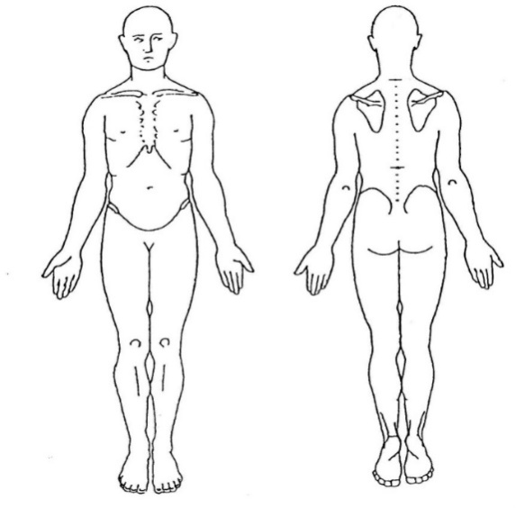
Which Body Part or Where is your problem?
Please write below or indicate on the picture
(NB We can only address one complaint on this form)

Do you have any pins and needles or numbness?
○No
○Yes …if so please tell us where:__________________

How did this start?

When did this Start (what date)? |  |  | Since your problem has started has it:  ○Got Better  ○Stayed the Same  ○ Got Worse
Name D.O.B
Have you had any treatment for this condition recently or for a previous episode
○Yes : Please give details:_______________________________
○No
Did it help?
○Yes
○No
Relevant medical history  Please select Yes or No for all of the following:  Condition Yes No  Heart Problems  Lung problems  Diabetes  Epilepsy  Major illness / Surgery  Family history of Rheumatoid Arthritis  Pins and needles / numbness  Fractures  Osteoporosis  Cancer (past or current)  Bladder or bowel problems  Nausea / vomiting  Headaches  Double vision  Unexplained weight change  Fainting / blackouts/ drop attacks  Problems with speech  Problems with swallowing  If you have answered yes to any of the above or have a condition not listed?Please give details: |  |  |  |  |  | Current medication  Medication Yes No  Have you ever taken steroids?  Have you ever taken anticoagulants (blood thinners e.g. aspirin / warfarin)  Please list your current medication:  Do you have any allergies:  ○No  ○Yes…if yes please give details:
Any Investigations for this current problem? | No | Yes |  | If Yes please give details (e.g result / date)
X-ray
MRI /CT scan
Ultrasound scan
Blood tests
Other tests
Name : DOB:

Please name up to five of your daily activities with which you have difficulty due to your condition and score them in respect to how well or otherwise you can carry them out. 10 able to do without any problem 0 unable to do them at all. e.g. going up stairs 6/10 (moderate difficulty).

Daily Activity  EgGoing Up Stairs | Score  Unable To Do Without any Problem  0 1 2 3 4 5 6 7 8 9 10
1: | 0 1 2 3 4 5 6 7 8 9 10
2: | 0 1 2 3 4 5 6 7 8 9 10
3: | 0 1 2 3 4 5 6 7 8 9 10
4: | 0 1 2 3 4 5 6 7 8 9 10
5: | 0 1 2 3 4 5 6 7 8 9 10

Please send this completed form to:  Email:  SC-TR.Coastal-MSK-Physios@nhs.net  Postal Return Address:  Physiotherapy Department  Bognor Regis War Memorial Hospital  Shripney Road  Bognor Regis  PO22 9PP  Fax 01243 623547  Unless you are a patient from Witterings Medical Centre or Pulborough Medical Group then please send to the appropriate address indicated to the right  When using this email address, Sussex Community NHS Trust cannot guarantee the security of this email, or be responsible for the security of any emails once sent or those in the sender's own email inbox. Once received, any personal details contained in this email will remain confidential in accordance with Sussex Community NHS Trust policies and procedures and relevant government legislation. |  |  |  |  |  | Return address for Pulborough Medical Centre Patients  Physiotherapy department  Pulborough Medical Group  Spiro Close  Pulborough  West Sussex  RH20 1FG  Return Address for Witterings Medical Centre Patients  Witterings Medical Centre  Physiotherapy Department  Cakeham Road  East Witterings  West Sussex  PO20 8BH

